2ND INTERNATIONAL SYMPOSIUM ON INTEGRATED FLOOD AND SEDIMENT MANAGEMENT IN RIVER BASINS FOR SUSTAINABLE DEVELOPMENT (FSMART) 2024
Theme: “Synergizing Science, Technology, and Policy Solutions to Strengthen Climate-Adaptive Integrated Water Resources Management Practices in River Basins”
Limketkai Luxe Hotel, Cagayan De Oro, Misamis Oriental, Philippines

AUTHOR’S GUIDELINES

Title Page
- The title page contains the research article title. The title should be bold, written in English, and the first letter of each word (except for prepositions of three letters or fewer, refer to APA Style Guidelines: https://apastyle.apa.org/style-grammar-guidelines/capitalization/title-case) should be capitalized as in the following example: Stakeholders’ Forum on Integrated Flood and Sediment Management: Basis in Writing Policy Recommendations.
- It contains the complete name of the authors (First Name, Middle Initial, and Last Name), their emails, and affiliation (department, institution, city, state, postal code, and country) as in the following example: College of Engineering, Isabela State University, Echague, Isabela, 3309, Philippines
- It contains the abstract of the research article. It should contain 200 to 250 words, encompassing the following significant parts of your manuscript:
- Introduction of research topic, context, gap, and major contribution of your study;
- General research objective and/or question;
- Research methodology (design, sample or participants, data collection techniques, and data analysis);
- Major findings of research (i.e., significant data points, trends, or outcomes that are central to your research, as well as significant implications of your study); and
- Conclusion and key recommendation from the study’s findings.
- It includes five (5) keywords, with each keyword separated by a comma

Main Manuscript

The main body of a research article should be within 6,000 to 8,000 words in English and include the following components: Introduction, Method, Results and Discussion, Conclusions and Future Works, Acknowledgment, Conflict of Interest, References, and Authors’ Bio Notes. The text of the manuscript should be in Microsoft Word. For the general format, the following details should be observed:
- Font: Arial Narrow, 12-point font.
- Line Spacing: 1.5
- Margins: 1-inch (2.54 cm) margins on all sides, except for the left margin, which should be 1.5 inches wide.
- Page Numbers: Located at the top right corner.

Introduction

- The introduction of your research paper should explain the research problem, including a discussion of previous and current studies related to the issue, thereby highlighting the research gap your study aims to fill. Likewise, the purpose of why you have conducted your research must be highlighted in this section including the potential contribution of the article.
- The objectives of the study should be clearly stated in this section of your paper.
- Literature citations should follow in-text citations following the 7th Edition of the APA Format (Refer to https://apastyle.apa.org/style-grammar-guidelines/citations).
- Each paragraph should be indented by 0.5 inches.

Methods

- This part of the research article should have a detailed discussion of the following aspects: research design, participants/respondents, locale of the study, research instruments, data collection procedure, analysis of data, and ethical considerations of your study. Separate paragraph/s should be written for each aspect of the research methods.
- In making subsections of this part of your paper, it should follow the prescribed level of heading based on the 7th Edition of APA Format, particularly level 2. (Kindly refer to this link: https://apastyle.apa.org/style-grammar-guidelines/paper-format/headings).
- In the ethical considerations section of the paper, especially if you deal with human participants, the research article should discuss different aspects to ensure the integrity of the research process and protection of participants such as informed consent, confidentiality and anonymity, ethical approval (accentuate the decision and/or major evaluation results from an Ethics Review Committee or Institutional Review Board or any kind of evaluation conducted to review the research process of the paper in relation to the rights of research participants), conflict of interest, and acknowledgment of participants’ rights.
- Each paragraph should be indented by 0.5 inches.

Results and Discussion
- It should contain the key answers to the research objectives. The findings of the study should be supported by figures and tables. Please do not send tables and figures in separate files and should be embedded in the paper itself. For table and figure setups, the research article should follow the 7th Edition of APA Format (refer to this link: https://apastyle.apa.org/style-grammar-guidelines/tables-figures). See the following examples of table and figure, respectively, which were taken from the APA Format:

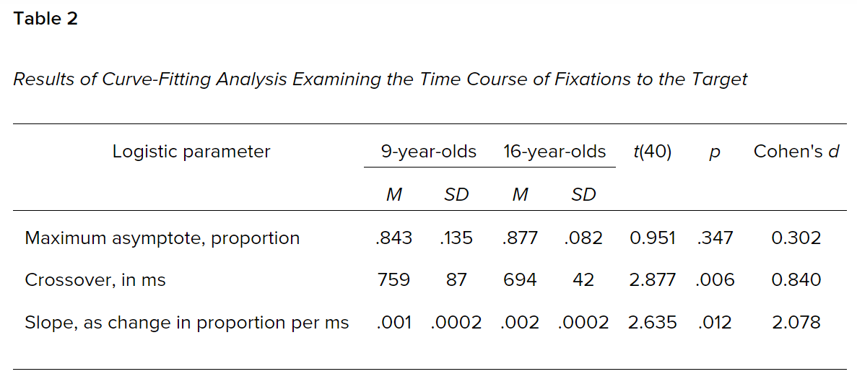
This is a sample table from the American Psychological Association (2024): https://apastyle.apa.org/style-grammar-guidelines/tables-figures/sample-tables

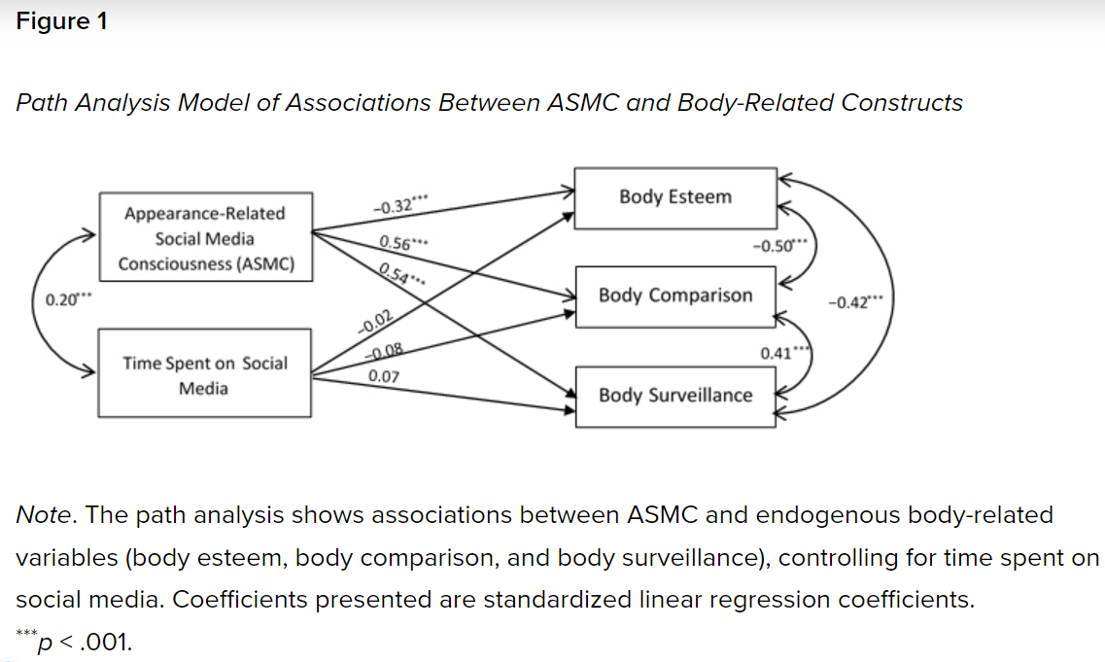
This is a sample figure from the American Psychological Association (2024): https://apastyle.apa.org/style-grammar-guidelines/tables-figures/sample-figures

- It should also include an interpretation of the results, a literature review to support your claims, and their implications for the broader field, potential applications, and future research directions.
- For qualitative studies and the results and discussion would feature short and long quotations from transcriptions, for quotations of fewer than 40 words, add quotation marks around the words and incorporate the quote into your textual presentation. On the other hand, start a block quotation on a new line and indent the whole block 0.5 inches from the left margin. For more information about formats on quotations, kindly refer to this link: https://apastyle.apa.org/style-grammar-guidelines/citations/quotations. Below is just an example of short and block quotations:

Of course, for students at the collegiate level, very often we ask them to write compositions in the various reading genres, and various forms of discourse – narrative, persuasive write-up, an expository paper, or a descriptive one – tasks include writing workshops wherein their classmates can critique and enrich another students’ work. (Teacher Participant 4)
***This is an example of a block quotation.

As a result, other researchers have proposed that the utilization of psychometric criteria for technical adequacy may lead to comparisons that reflect unfairly on the new forms of performance assessment, such as the integrated assessment, which are “more time-consuming and subjective than standardized tests and may not meet the statistical assumptions for some forms of analysis” (Brindley, 2001, p. 400).
***This is an example of a short quotation.
- Each paragraph should be indented by 0.5 inches.

Conclusion and Future Works
- This section of the research paper should highlight the study’s practical implications, emphasizing their relevance and contribution to the current body of knowledge.
- It should also include an acknowledgment of the study’s limitations of the paper and the potential impact of the results to allow other researchers to look into other possibilities of another research problem.
- It may contain suggestions for future research based on the study’s outcomes and limitations, or possible applications and extensions of the research.

Acknowledgment
- This section of the paper includes acknowledgments to individuals whom the author wishes to thank or to the collaborating agency that provided funding for the realization of the study. In case no acknowledgment will be given to someone or any organization, you may delete this section of the paper.

Conflict of Interest
- This section of the paper is a declaration of personal and institutional financial and non-financial interests, review and editorial conflicts, funding and support transparency, institutional policies and procedures, and measures to mitigate the conflicts. Declaring any conflict of interest to provide comprehensive and transparent information helps build trust in the research process and ensures that any potential biases are appropriately managed. If there is no conflict of interest, you may consider the following statement for this section: The authors declare that there are no conflicts of interest regarding the publication of this paper.

References
- The number of references should be at least 15 references. It should also be as recent as possible from the last five (5) to 10 years. Only those references that can be found on the paper should be included.
- The references should follow the current format of the 7th Edition of the Publication Manual of the American Psychological Association (APA).
- Refer to the following examples for guidance:

Journal Article
Author, A.A., & Author, B.B (Year). Title of the Article. Name of the Journal, Volume, Issue, Page. DOI or URL if available.

Bird, F. (2020). A defense of objectivity in the social sciences, rightly understood. Sustainability: Science, Practice and Policy, 16(1), 83-98. https://doi.org/10.1080/15487733.2020.1785679.

Books
Author, A. A., & Author, B.B. (Copyright Year). Title of the Book with Edition. Publisher. DOI or URL if available.

Douglas, D. (2014). Understanding language testing. In B. Comrie & G. Corbett (Eds), Understanding Language Series. Routledge. https://doi.org/10.1177/0265532210373604

Web Page
United Nations Educational, Scientific, and Cultural Organization. (2020). Alternative Solutions to School Closure in Arab Countries to Ensuring that Learning Never Stops. https://en.unesco.org/news/alternative- solutions-school-closure-arab-countries-ensuring- learning-never-stops

News Article
Calonzo, A. (2020, October 23). Philippine Covid Cases Drop as Testing Falls Below Target. Bloomberg. https://www.bloomberg.com/news/articles/2020-10- 23/philippine-covid-cases-drop-as-testing-falls-below- target
- For more kinds of reference formats, kindly refer to this link: https://apastyle.apa.org/style-grammar-guidelines/references/examples
Authors’ Bio Notes
- This section includes a 50-word profile about the authors, highlighting their research interests and great accomplishments in their field of study.

Title of the Paper
¹Author1 (First Name, Middle Initial, and Last Name) and email
²Dela Cruz, Juan A., juandelacruz@gmail.com
³Author3, email
¹affiliation (department, institution, city, state, postal code, and country) of author 1
²College of Engineering, Isabela State University, Echague, Isabela, 3309, Philippines
³affiliation (department, institution, city, state, postal code, and country) of author 3

Abstract

(Replace the text with your abstract) It should only contain 200 to 250 words, encompassing the following significant parts of your manuscript: Introduction of research topic, context, gap, and major contribution of your study; General research objective and/or question; Research methodology (design, sample or participants, data collection techniques, and data analysis); Major findings of research (i.e., significant data points, trends, or outcomes that are central to your research, as well as significant implications of your study); and Conclusion and key recommendation from the study’s findings.

Keywords: Keyword1, Keyword2, Keyword3, Keyword4, Keyword5

Introduction
(Replace this text with your introduction). The introduction of your research paper should explain the research problem, including a discussion of previous and current studies related to the issue, thereby highlighting the research gap your study aims to fill. Likewise, the purpose of why you have conducted your research must be highlighted in this section including the potential contribution of the article.
The objectives of the study should be clearly stated in this section of your paper. Literature citations should follow in-text citations following the 7th Edition of the APA Format.

Methods
(Replace this text with your methods). This part of the research article should have a detailed discussion of the following aspects: research design, participants/respondents, locale of the study, research instruments, data collection procedure, analysis of data, and ethical considerations of your study. Separate paragraph/s should be written for each aspect of the research methods.
In making subsections of this part of your paper, it should follow the prescribed level of heading based on the 7th Edition of APA Format, particularly level 2.

Results and Discussion
(Replace this text here with your actual results and discussion). It should contain the key answers to the research objectives. The findings of the study should be supported by figures and tables. Please do not send tables and figures in separate files and should be embedded in the paper itself. For table and figure setups, the research article should follow the 7th Edition of APA Format
It should also include an interpretation of the results, a literature review to support your claims, and their implications for the broader field, potential applications, and future research directions.

Conclusion and Future Work
- (Replace this text with your actual conclusions). This section of the research paper should highlight the study’s practical implications, emphasizing their relevance and contribution to the current body of knowledge.
- It should also include acknowledgement of the study’s limitations of the paper and the potential impact of the results to allow other researchers to look into other possibilities of another research problem.

Acknowledgment
(Replace this text with your acknowledgment). This section of the paper includes acknowledgments to individuals whom the author wishes to thank or to the collaborating agency that provided funding for the realization of the study. In case no acknowledgment will be given to someone or any organization, you may delete this section of the paper.

Conflict of Interest
(Replace this text with your conflict of interest). This section of the paper is a declaration of personal and institutional financial and non-financial interests, review and editorial conflicts, funding and support transparency, institutional policies and procedures, and measures to mitigate the conflicts. Declaring any conflict of interest to provide comprehensive and transparent information helps build trust in the research process and ensures that any potential biases are appropriately managed. If there is no conflict of interest, you may consider the following statement for this section: The authors declare that there are no conflicts of interest regarding the publication of this paper.

References
- Bird, F. (2020). A defense of objectivity in the social sciences, rightly understood. Sustainability: Science, Practice and Policy, 16(1), 83-98. https://doi.org/10.1080/15487733.2020.1785679.

- Douglas, D. (2014). Understanding language testing. In B. Comrie & G. Corbett (Eds), Understanding Language Series. Routledge. https://doi.org/10.1177/0265532210373604

- United Nations Educational, Scientific, and Cultural Organization. (2020). Alternative Solutions to School Closure in Arab Countries to Ensuring that Learning Never Stops. https://en.unesco.org/news/alternative-solutions-school-closure-arab-countries-ensuring-learning-never-stops

Authors’ Bio Notes
Dr. Juan Dela Cruz is ……

